Humanitarian Assistance and Fertility Decisions: At what extent Emergency Social Safety Net (ESSN) targeting criteria had influenced the fertility rates and fertility calendar of Syrian refugees in Turkey

Abstract

Turkey, as the country with the highest number of refugees, is currently a home to 3.7 million Syrians who had to flee from their country due to the conflict started in 2011. Since December 2016, refugees from all nationalities in Turkey can apply for the Emergency Social Safety Net (ESSN), the largest humanitarian programme ever funded by the European Union. ESSN is an unconditional cash transfer programme that targets households using the demographic criteria to select the most vulnerable among the refugee population residing in Turkey. Two out of six of the demographic criteria were dependency ratio equal or greater than 1.5 and having at least 4 minor children. These criteria are questioned based on whether they may encourage families to have more children or not. This article aims to answer this question by adopting an evidence-based approach. To do so, we compare the fertility rates of ESSN beneficiaries and ineligible applicants by using the Propensity Score Matching. Our results show that the existence of the ESSN targeting criteria does not encourage ineligible households to have more children in order to become eligible for the ESSN. It can, however, encourage households to have children more quickly than they would otherwise.
Key words: ESSN, cash-based transfers, fertility, targeting, Turkey, Syrian refugees, propensity score matching

Introduction

Turkey currently is a host to 4 million refugees, the highest among refugee-hosting countries. The majority of them are from Syria; by April 2019 around 3.6 million Syrian refugees had been registered in Turkey. Most of those Syrian refugees arrived in Turkey have been given a temporary protection status without a prior examination to be accepted as a refugee due to this mass migration influx within the context of the ‘open door’ policy of the government. Moreover, Turkish government has adapted existing systems to include refugees in national systems, such as identity and address registration, and provided access to basic services, such as education and health care. A range of national NGOs, INGOs, UN agencies and other international organizations also have been working actively to support the refugee population.
Most refugee arrivals have started in 2013 and the majority of them arrived in Turkey in 2014 and 2015 when the civil war intensified in Syria. Towards the end of 2015, around 1 million refugees from Turkey were crossing borders from Turkey to reach Europe due to dire conditions followed by this massive influx. Many Syrian refugees had to use severe coping strategies due to lack of regular income opportunities as the temporary protection does not give the right to access the job market easily and this has caused them having difficulties in meeting their basic needs.
Due to the increasing number of refugees hosted by Europe, European Union (EU) and Turkey agreed on a deal to keep the migration under control. The EU had given Turkey a total of €6 billion in two tranches to improve the worsening conditions of Syrians and to help with scarce resources of Turkish government to support the 3 million refugees. The idea behind was to provide money to Turkish government to help with overwhelmed government resources to provide better lives to Syrian which would eventually provide a more stable environment in Turkey.
The fund for this deal is called ‘The EU facility for Refugees in Turkey’. The budget was distributed with different actors including UN and governmental organizations, and NGOs to support different areas such as protection, health, basic needs, and education. Emergency Social Safety Net (ESSN) was categorized under basic needs and it was one third of the overall budget both for first and second tranches of the deal. In order to help refugees with providing their essential needs, the most vulnerable ones in Turkey are supported by this programme. ESSN was launched in November 2016 and is an unconditional cash-based transfer programme. It is the largest humanitarian program that has ever been funded by the EU which provides beneficiary households with a debit card that gives them access to a fixed amount of money each month to purchase what they need most, whether it be food, fuel, rent, medicine or to pay bills. Every month, the debit card is credited with 120 Turkish Lira (TRY) (13 euros) for each member of the family. Families also receive periodic “top-ups”. Those with a severe disability receive an additional monthly top-up payment of TRY 600. Refugees are similarly eligible for top-ups based on the size of their household. Currently ESSN has around 1.8 million beneficiaries.
The programme was implemented by World Food Programme (WFP), Turkish Red Crescent (TRC) and the Ministry of Family and Social Policies (MoFSP) from November 2016 until March 2020. Currently, the programme continues with the same principles in collaboration with the same national partners and International Federation of Red Cross and Red Crescent (IFRC) au lieu de WFP. One of the main importance of the ESSN was that it aimed to align with the already existing social system in Turkey through this collaboration. Refugees apply for the ESSN through SASF (Social Assistance and Solidarity Foundations) which is a foundation that provides social assistance to Turkish nationals under the MoFSP.
To apply for the ESSN, all refugees need to be registered in Turkey under DGMM (Directorate General of Migration Management) and they need to be registered in their place of residence. Upon their application to SASF located in their place of residence, their eligibility is decided based on the demographic family composition of the refugee households. Due to the need for a rapid programme scale-up, ESSN stakeholders agreed to use demographic criteria as proxy indicators of household welfare. WFP selected the specific demographic criteria based on a regression analysis of household data, using per capita expenditure as the independent variable, measuring welfare at the very beginning of the programme. Additional ‘extremely vulnerable’ criteria were added based on data from other contexts, and protection concerns. The six criteria are listed below:

1. Households with a dependency ratio equal to or above 1.5
2. Households with four or more children
3. Elderly headed households (no adults aged 18-59)
4. Single females living alone
5. Households with at least one disabled member (certified at 40% or more disabled)
6. Single parent households (only one adult aged 18-59 with at least one dependent)

All refugees applying for the ESSN were registered through ‘Integrated Social Assistance System (ISAS)’ which is also actively used for Turkish nationals. The paper-based social assistance procedures were standardized, integrated, and converted into an electronic system through the development of ISAS (MoSFP 2017). This system helps to connect all data resources collected within the government and helps to have them in one place. This system initially used to target Turkish nationals who are in need of assistance through the score they get based on their asset ownership, salary and other information that shows their current socio-economic situation. For the ESSN, ISAS was slightly adjusted based on the targeting criteria that is used for the refugee population. The system admits households that meet at least one of the demographic targeting criteria above as eligible. As the system is integrated with the other data, when the family composition changes, some households can be automatically deemed ineligible if they no longer meet the demographic criteria.
Throughout the duration of the programme, queries and criticisms have arisen that the demographic criteria – particularly the criteria pertaining to four or more children and the dependency ratio – are encouraging demographic changes among refugee families. The most common criticism is that this programme encourages refugee families to have more children. Although these conjectures have not been substantiated in any way, a wealth of ESSN administrative data is available, which could potentially provide empirical evidence to substantiate these claims.
Given the criticisms and queries, WFP specifically requested analysis on the fertility rate and trends among eligible and ineligible households from the Demography Institute of the University of Paris 1 Pantheon Sorbonne (CRIDUP) to provide evidence-based response to this criticism and help to launch discussions on better targeting methods for future humanitarian aid programmes as part of lessons learnt exercise. In the light of this approach, this article mainly covered the following question: Has the ESSN programme caused any demographic changes in terms of fertility and/or encouraged early marriages among applicant households among Syrian refugees?
This article had two main results. Firstly, the ESSN programme did have an impact on fertility trend; the study confirmed that the ESSN had a slight positive impact on fertility rates among beneficiaries as compared to ineligible applicants. Beneficiary households are more likely to have a higher number of children (+0.06 more children per year, per woman) compared to ineligible households. The latter was about the birth order as the study reveals that the ESSN has a slightly differential impact on fertility calendars, affecting the timing of having the first, second or third child among eligible and ineligible households. Ineligible households tended to have the 3rd child 1 month earlier than the beneficiary households.

Migrant’s fertility and impact of cash transfers: review

The impact of Forced Migration on Fertility

The most common type of research on migration and fertility focuses on migration from high fertility to low fertility countries. The fertility and migration research linked to forced migration is very rare. Despite this limitation, in the light of existing literature on the subject, a study from Coleman (1994) suggests that demographic transition is expected to be initiated or accelerated by the new environment, and that convergence with the demographic regime of the host society will take place, much faster than if the migrants had remained in the country of origin (Coleman 1994). Another study shows that when people move from one country to another, they change their cultural, social, and economic environment, as well as their individual position in the environment where they reside. This will result in a change that will be reflected on reproductive behaviour (Fargues 2006). On the other hand, some other studies show that migrants can maintain similar childbearing patterns from country of origin and even create a ‘defensive structuring’ that might include high fertility and hostility to family planning (Siegel 1970). In all cases, while country of origin and destination can tell about the overall childbearing behaviour of migrant populations, there is a need for dynamic understanding of the connection between migration and childbearing that recognizes conditions at destination along with the impact of social and economic conditions facing various migrant groups and the effects on their reproductive decision-making process (Desiderie 2020).
In that sense, the impact of forced migration on fertility slightly differs. The forced migration cycle is typically not similar to the regular migration as the effect of forced migration on fertility may vary across these different stages (Agadjanian 2018). One rare study on forced migration and fertility suggests that fertility often declines in the immediate aftermath of the crisis and related dislocations (Hill 2004). This decline can also be seen as disintegration from society and identity (Randall 2004). Another crucial point is that access to contraceptives play an important role in fertility decisions. Women who are living in conflict areas including refugees are more prone to poor sexual and reproductive health practices and limited control over decisions related to family planning (Hynes et al., 2002; Lam et al, 2012). Literature argues that fertility may increase to replace dead and lost children, or it may fall as a result of uncertainties of refugee life and it usually rebounds in the post-emergency stage so that lifetime fertility of forced migrants is typically comparable to that of the rest of the population and long- term effects of forced displacement on fertility are rather limited (McGinn 200; Hill 2004; Randall 2004)

The methods for calculating the fertility in the context of migration also matters due to disruptions throughout the reproductive life cycle of migrant women. Total Fertility Rate (TFR) is very efficient in computing overall fertility rates among stable populations; however, for populations that experience social disruption or postponement such as in the case of forced migration, TFR can look higher than normal (Toulemon and Mazuy 2003; Toulemon 2004; Volant, Gilles and Héran 2019). This synthetic calculation sums the observed age-specific fertility rates as demographers normally do when making period estimates. It assumes implicitly that fertility is a function of age, and that the age profile gives a reasonable idea of fertility through the life course. This assumption is not valid for immigrants nor refugees, whose fertility profiles are significantly influenced by the moment of migration, i.e., highly specific to their age at migration. (Toulemon, Fertility among immigrant women: new data, a new approach 2004). Thus, addressing migrant fertility falls within the scope and conjunction of a dual process: disruption in fertility calendar and in fertility rate (i.e., the number and the timing of their children).

Fertility rates in Syria

As more than 90% of ESSN beneficiaries are Syrians, this part of study focuses on the specific case of Syrian refugees. Prior to Syrian conflict, Syrian fertility rates declined by nearly half since the late 1970s; this decline has slowed and come to a stagnation since the early 2000s in Syria. Current data shows that, Syrian fertility had a linear decline since 2009 where it was measured as 3.51 in 2009 and in 2017 TFR estimated as 2.8 in Syria (World Bank 2020).
For the Syrians who had to flee to the neighbouring countries, there has been continuing efforts for data collection. Both Jordan and Turkey included a Syrian sample within Demographic Health Surveys (DHS), and data collection took place in 2017 and 2018 respectively. The results from both reports shows that in Jordan, TFR for Syrian refugees was 4.7 while in Turkey it was calculated as 5.3 (Department of Statistics (DOS) and ICF 2019; Hacettepe University Institute of Population Studies 2019). In 2016 Labour the Jordan Labour Market Panel Survey (JLMPS), found lower fertility rates found upon their arrival in Jordan, which was 4.9 births per woman as of 2009 in Syria and in 2016 it was 4.4 (Sieverding, Berri and Abdulrahim 2018). As mentioned previously, the reported TFR for Syrian refugees is likely overestimated due to the bias towards migrant populations (Toulemon and Mazuy 2004; Toulemon 2004).
It should be noted that the TFR varies across different regions of Syria, creating strong contrasts between Syrian governorates. According to Youssef (2012), fertility rates were higher in Northern Syria, especially in Idlib, Raqqa (TFR>5), in Aleppo and Al-Hasakeh (TFR>4) compared to Damascus and Homs (TFR<4). Most Syrians living in Turkey originate from bordering regions in Syria. According to the most recent findings, more than half of Syrians who have migrated to Turkey originate from Aleppo, followed by Idlib, Hama and Raqqa (World Food Programme 2020).

The Impact of Cash Transfer Assistance on Fertility

In some instances, financial aid policies explicitly aim to increase fertility, such as family policies in France. However, it is challenging to estimate fertility outcomes due to these government policies, which aim to increase fertility, i.e., the government providing financial support to families for each of their children. Generally, these family policies produce a windfall effect on fertility, for example when people who intended to have children anyway, will have one sooner than expected (Thévenon 2004). On the other hand, there are financial assistance policies that aim to fight poverty without increasing fertility which is also the case for the ESSN. In this case, there may be an unintended impact on fertility. There is already some research on the unintended effects of assistance and the fact that could lead beneficiaries to have no other financial income (Purière 2012). That means that they might become fully dependent on the assistance. There are also some other unwanted impacts focusing on fertility behaviour. According to the literature, the debate on the impact of financial aid policies on fertility dates back to Malthus, who, in the early 19th century opposed financial support for vulnerable populations, referred to as “poor laws". Malthus, Smith, and Ricardo feared that “it would increase the fertility of the unemployed and underemployed” (Clark 2019).
Despite the limited evidence on the impact of cash-based transfers on fertility, some empirical studies suggest that both conditional and unconditional cash-based transfer programmes might be an incentive for some households to have more children. For example, Whittington et al. (1990) found that tax exemptions for dependents affected the decision to have a child and increased the fertility rate in some cases. Acs (1996), on the other hand, concluded that there was no impact of financial support policies for young mothers on their fertility rates.
ESSN is an unconditional cash transfer programme which aims to provide basic needs to the off-camp refugee population living in Turkey. Considering that this programme targets the most vulnerable households that identify with proxy demographic indicators, in practice, it is conditioned by these demographic criteria. Independent from whether the ESSN has a direct impact on fertility, in order to carry out this study successfully, it is important to consider all conditions where the existence of such a programme could become an incentive to have more children, which would be the case for any other humanitarian aid.

Hypotheses

The main objective of this study is to determine whether ESSN assistance encourages ineligible households to have more children in order to become eligible. More precisely, critics posit that the demographic criteria of the ESSN – particularly the four or more children criterion and the dependency ratio equal criterion (equal to or greater than 1.5 children per parent, 3 children for two parents) – is encouraging demographic changes among refugee families. Indeed, for the ineligible households, a couple with 2 children under 18 and two parents can become eligible if they have another child (the dependency ratio becoming equal to 1.5). The above examples demonstrate how the existence of this programme may act as a fertility incentive. This could not only be true for beneficiaries but also for ineligible applicants, who could choose to have more children in order to meet the demographic criteria for eligibility.

The below hypotheses intend to examine how fertility could potentially be affected by the ESSN demographic criteria.

Fertility Behaviour
H1a The ESSN has no impact on fertility: Both beneficiaries and non-beneficiaries have similar fertility rates.
H1b The ESSN increases fertility rates among beneficiaries: Beneficiary households are more likely to have more children after becoming eligible.
H1c The ESSN increases fertility rates for non-beneficiaries: Non-beneficiary households are more likely to have children in order to become eligible for the ESSN programme by having 4+ children and/or a dependency ratio equal to or greater than 1.5.

Calendar Effect and Birth Rank
H2a The ESSN has a differential impact on fertility according to the birth order of children. The probability of having the 1st, the 2nd or 3rd child is not equally affected by the ESSN demographic criteria.
H2b The ESSN has an impact on fertility calendars. The intervals between successive births are different for ineligible households than for those households that will meet the ESSN demographic criteria if they have a 3rd child, or for beneficiaries who are already part of the ESSN.

Methodology

In order to answer the question of potential impact of the ESSN on fertility behaviour, both beneficiary and non-beneficiary households should be compared to observe potential differences on their fertility outcomes. As these two groups are highly affected by the demographic criteria due to this particular demographic selection for the ESSN, it is not possible to distinguish the differences because of selection bias. As a result, propensity score matching method has been used to eliminate bias on fertility analysis of these two groups in order to make them comparable.

Propensity score matching

The treatment effect estimation method neutralizes the selection bias by conditioning programme eligibility on observable characteristics that allow some comparability between eligible and ineligible individuals/households. In other words, the propensity score $P (T = 1 X) = e(X)$is the probability for an individual to be treated given these covariates (denoted by $X$). Therefore, a crucial assumption (called unconfoundedness) will be that conditional on some observable covariates, the studied outcome will not depend on treatment assignment i.e.

$$Y (0),Y (1) ⊥ T |X$$

A second important assumption is overlap: it requires that there is no perfect predictability, i.e.

$$0 < e(X) < 1$$
The first step of the estimation strategy starts with creating the propensity score, which can be seen as the probability of being treated. The propensity score is estimated parametrically through a logit model. Let e(x) denote the propensity score, the treatment dummy for individual i, and Xi the vectors of the covariates in the model:

$$e(x)=E(T_{i}│X_{i}=x)=\frac{e^{Xβ}}{1+e^{Xβ}}$$

The second step of the analysis is to use the propensity score to find comparable treated and untreated individuals and, therefore, estimate treatment effects.
There are several methods to estimate propensity scores and to compute treatment effects. For the purpose of this study, only the two methods used will be presented:
The first method is nearest neighbour matching which aims to match individuals with similar propensity scores. According to the guidance provided by the literature (Caliendo and Kopeinig 2008), we chose the method of matching with replacement, in order to decrease the bias of our estimates as individuals will be matched to closer counterfactuals on average. Also, the replacement makes our estimates independent to the order in which the observations are matched. Moreover, each observation is matched with two nearest neighbours – which is called oversampling. Even though this might increase the bias of our estimates (as the second match is worse than the first), it leads to a smaller variance in our estimates as we use more information in the process.

The second method we chose to use is stratification (also called blocking). This aims at partitioning the common support into a number of strata in which the treatment effect is estimated through the mean difference in outcomes between treated and controlled observations. Those effects are averaged over the subclasses.
These two methods eventually allow us to estimate the programme’s treatment effects. Note that the results by subgroups, presented in a second step, are only estimated through nearest neighbour matching.

Treatment effect estimates

Once the matching or the stratification are done, the last step is estimating treatment effects. In order to assess the robustness of our results, we applied several methods:

- Difference in means: The most straightforward estimate of average treatment effect in the case of matching is the difference in means between treatment and control outcomes. In the case of nearest neighbour matching, it translates by the average of differences between each individual’s outcome and its counterpart’s outcome. Note that the counterpart’s outcome is defined as a weighted mean of those of the individual’s nearest neighbour. In the case of stratification, it is simply a weighted mean of the difference between average outcomes of treated and controls in each stratum.
- Regression: A second way of estimating average treatment effect is to run a regression on the matched/stratified data frame where the coefficient of the treatment dummy is interpreted as the treatment effect. Note that in the case of the stratified data frame, the regression is running on all strata and the treatment effect is averaged over strata. Here, the first regression was run with no covariates and the second one, with several controls.

Data Sources: ESSN Database

Presentation of the ESSN database

The data we based this study on comes from the administrative records of the Emergency Social Safety Net programme. As mentioned earlier, this data is collected through the ISAS system which is part of the already existing national system. It contains comprehensive socio-demographic information on individuals and households who registered with the programme. It includes household level information which includes age, sex, and relation to the head of household of all members reported monthly. Additionally, it also includes information on their eligibility status for each month as the system automatically deems households eligible or ineligible based on their family composition and if they meet the demographic criteria which is assessed at the beginning of every month. The families have one unique ID number for each household that makes possible the comparison of households. Individuals are registered with their ID numbers given upon their registration in Turkey. Some individuals can be attributed to new family members once they change their composition which can be matched through their unique ID numbers.
The ESSN administrative data was available from December 2016 (the beginning of the programme) until April 2019 (latest available data at the time of the analysis) on a monthly basis. Monthly data is updated including those who newly applied to the programme and those who are not applicants anymore which required some elimination within the dataset to have households who have been in the database constantly without a beneficiary status change.

Data pre-processing

The estimation of the treatment effect requires a database containing information at the household level on eligibility status as well as on the explanatory data and also on other controls. For instance, the mother’s age and the number of children present in the household were needed for the processing.
Given that we aim to study the programme’s impact on fertility, we need information on how many children a woman has and the month she gives birth to those children. Therefore, in order to be able to identify the number of children a woman has, we only kept the households where there was only one woman of reproductive age (age between 15 to 49) per household.
Furthermore, in order to investigate the effect of the programme on the event of a household having an additional child, we needed information on whether a birth happened following the time where the data was available. Thus, we only kept those households that are still present in the ESSN databases one year after the time of observation (from April 2018 to April 2019).
As the matching algorithm does not tolerate missing values, we had to discard those households with a missing value. However, this did not affect the analysis as the number of households with missing values was fairly small.
In the end, the final dataset used for analysis contained 225,949 households (of the 402,326 households initially covered by the ESSN database). Even though they slightly differ, the distribution of the explanatory variables and of the treatment indicator among the remaining households was not significantly different from that of the discarded ones.

Results

Descriptive Analysis

Descriptive analyses are based on beneficiaries and ineligible applicant data for both individual and household datasets as of April 2018. The applicant data from April 2018 was chosen because it corresponds to one year before the last available database (April 2019). This allows for the identification of households that either did, or did not have children at this time, but remained in the programme database the following year. The analysis found that the characteristics of eligible and ineligible applicants did not vary significantly from one month to the next, which led us to use only April 2018 and April 2019 in the final report.

Context variables

In April 2018 the total population of eligible and ineligible individuals numbered 2,032,419 individuals (of which 1,301,941 were eligible), distributed between 402,326 households. The average size of an eligible household is slightly less than 6 (5.83) people, and slightly over 4 (4.08) people for an ineligible household. Furthermore, the structure of these populations differs substantially in terms of age (see Figure 1 below).
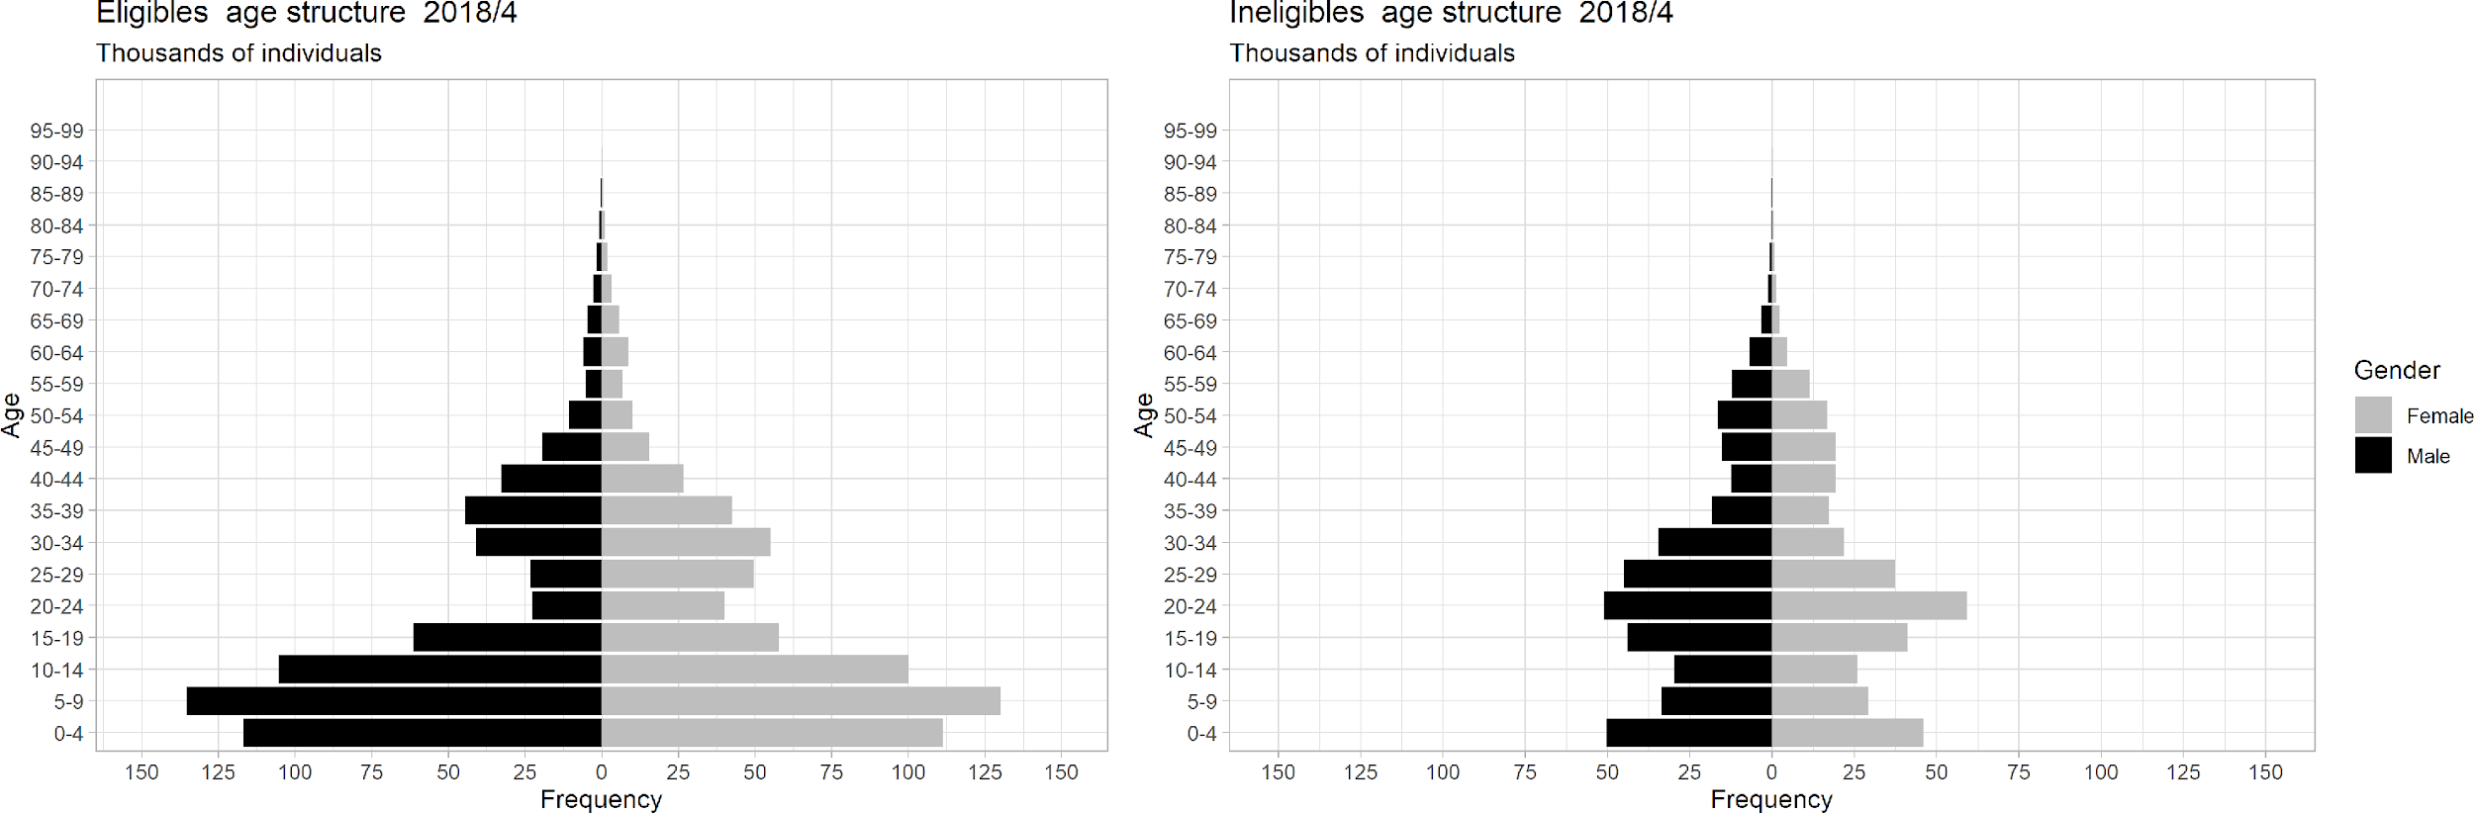
Figure 1 Age pyramid of eligible and ineligible applicants (thousands of individuals)

While more than half (54%) of the eligible households meet at least two eligibility criteria, around 75% of them meet the criteria of dependency ratio higher or equal to 1.5 which overlaps with 4 children criteria that is met by 50 percent of beneficiaries. The majority of applications for the ESSN are Syrian nationals, who represent 90% of eligible and 88% of ineligible applicants. In addition, the other most represented nationalities are Iraqi (7% of both eligible and ineligible applicants) and Afghans (3% of eligible and 2% of ineligible applicants).
  - Demographic outcomes

Fertility of Eligible and Ineligible Applicants

The demographic differences between eligible and ineligible applicants are intrinsically linked to the programme eligibility criteria. This induces an important selection bias, making any raw comparison of the fertility behaviours between eligible and ineligible individuals difficult.

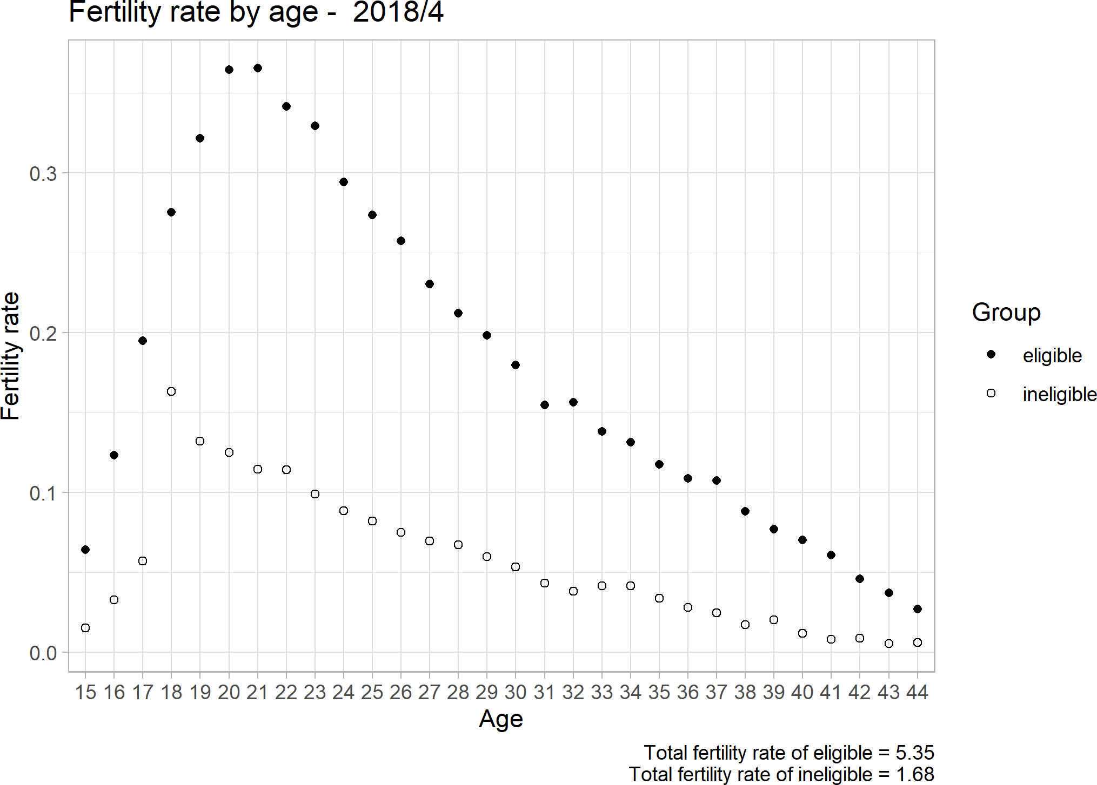
Figure 2 Fertility rates of eligible and ineligible women

In order to estimate these fertility rates, we selected only the households where the only adult present in the household was one woman aged between 15 to 49. The households with only one-woman present were selected, as it is assumed that they are the mother of any new-born children, making it possible to calculate a TFR from the ESSN dataset. We then filtered for households with the presence of a child aged less than 1 year. Averaging these numbers led to Figure 2 where TFR was 5.35 for beneficiaries and 1.68 for ineligible applicants. However, because the number of children in a household is only one of the acceptance criteria, this simple observation does not enable us to conclude whether the programme has any impact on fertility.

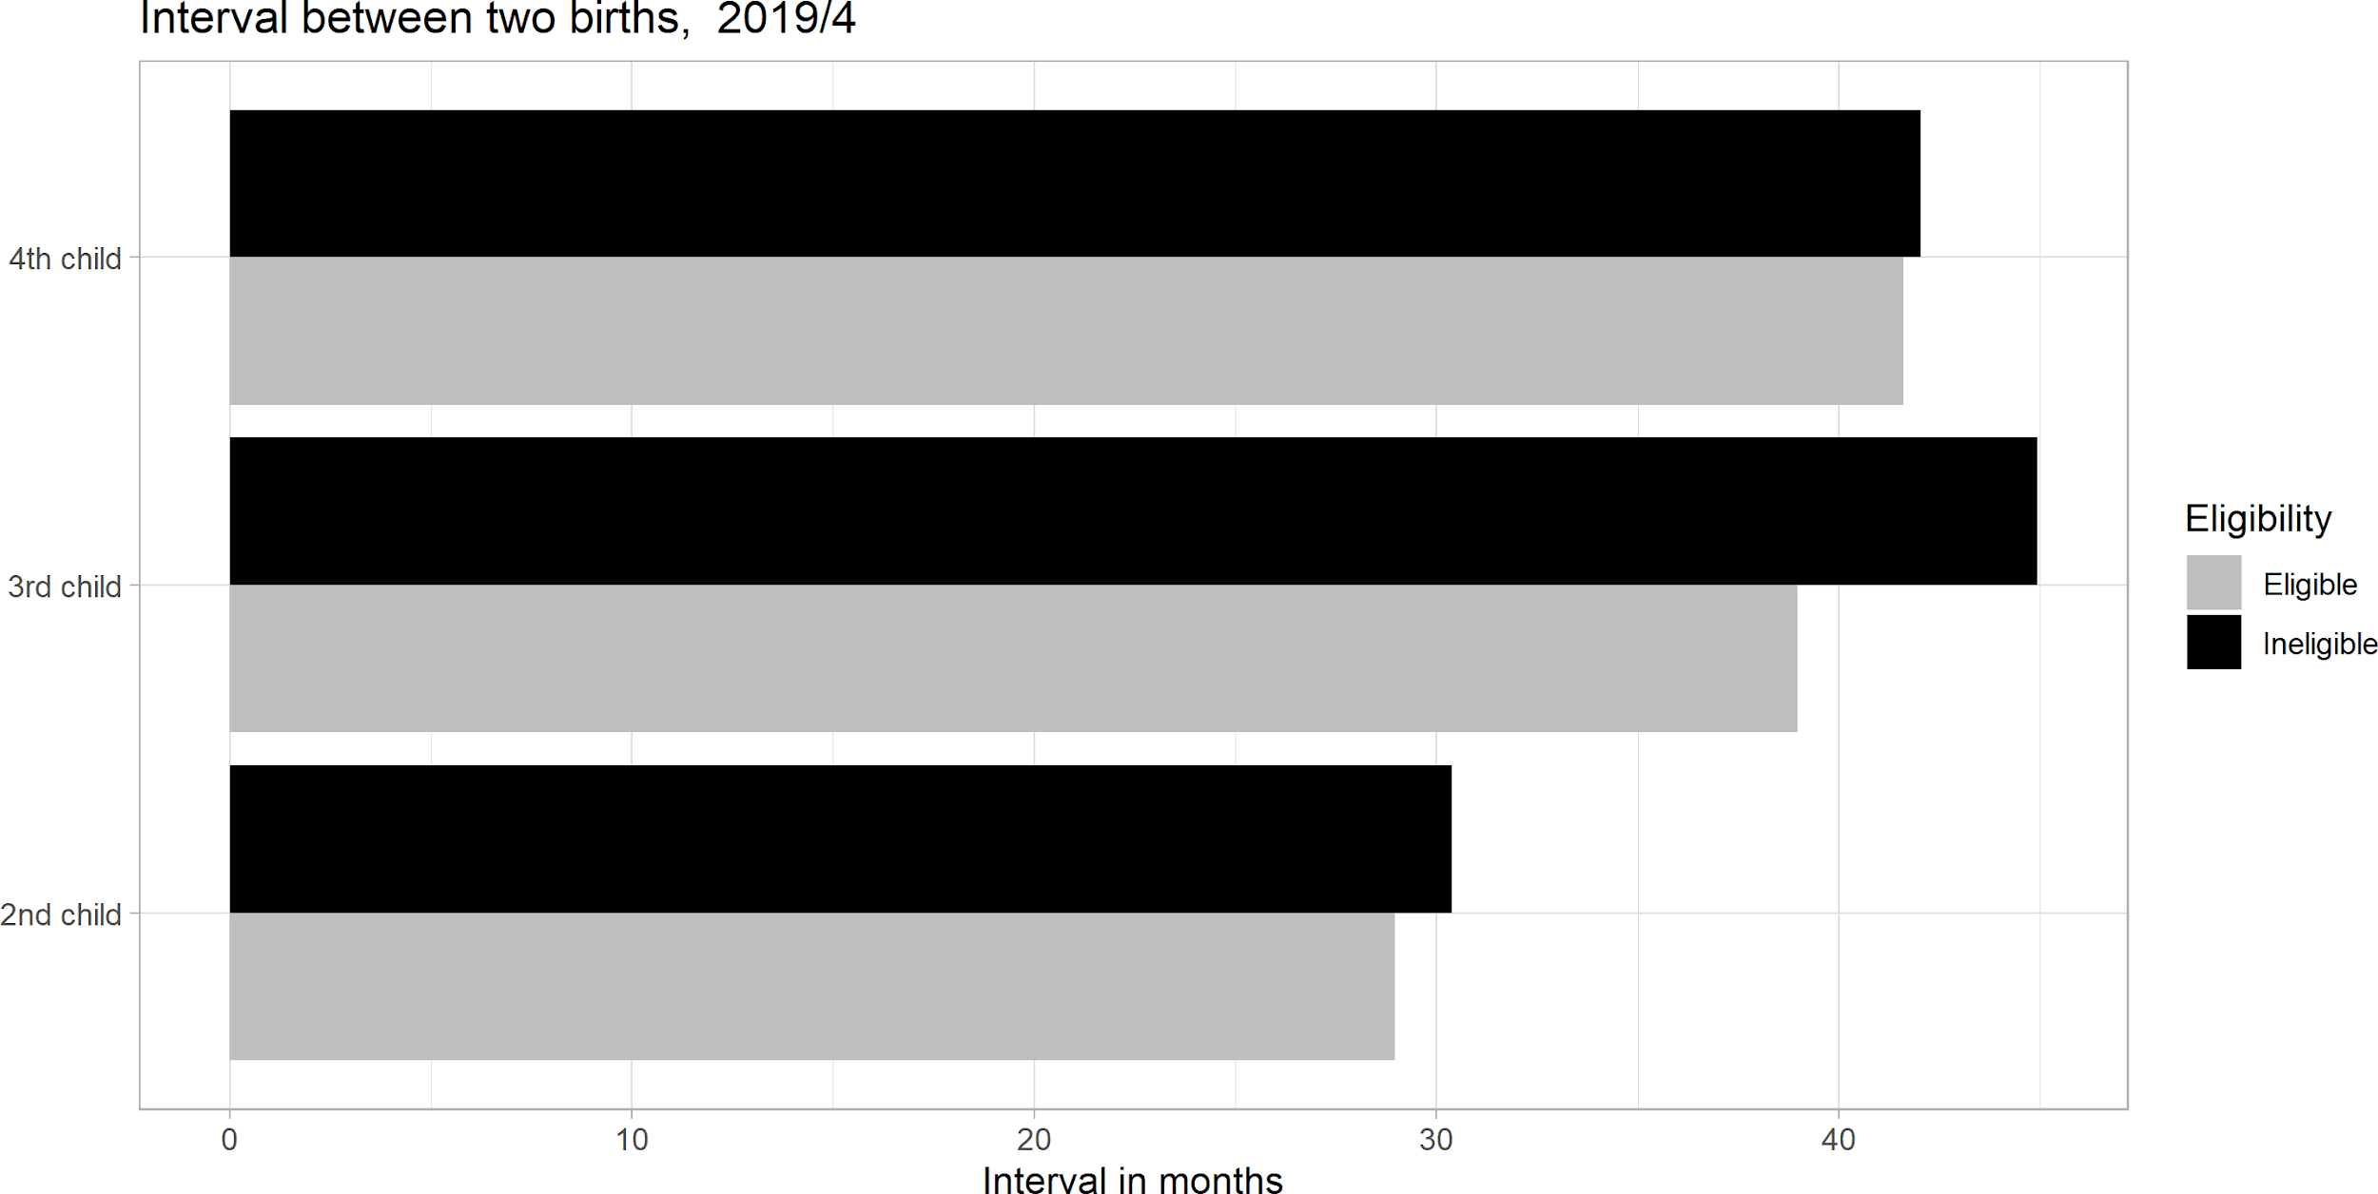
Figure 3 Birth intervals for 2nd,3rd, and 4th child by eligibility status
Based on the demographic criteria of having at least 3 children to become ineligible households, we also analysed the birth intervals by eligibility status. As Figure 3 demonstrates, the interval between the first and second births seems considerably lower compared with the intervals between the third and fourth as well as between the fourth and fifth births.

Comparison with Syrian population before the conflict

In order to provide more insight on the fertility rate of Syrian refugees in Turkey, we also compared their fertility rates with the Syrian population before the war. We applied the same selection technique of filtering households to measure TFR as we used when analysing the ESSN database in order to have the same results for the Syria Family and Health Survey (Syria PAPFAM 2009). Additionally, to ensure comparability between our samples, we compared those individuals from the SFHS 2009 living in the northern governorates (Aleppo, Idlib, Raqqa and Hasaka) to the Syrians in the present ESSN database.

As discussed earlier, fertility rates tend to decrease for migrating populations upon their arrival in a host country. Indeed, in one example resulting from this comparison (shown in Figure 4), we found that, across ages, Syrian refugees living in Turkey have lower fertility rates (with an estimated total fertility rate of 3.07) than those of Syrian women prior to the war (with a total fertility rate of 5.13).

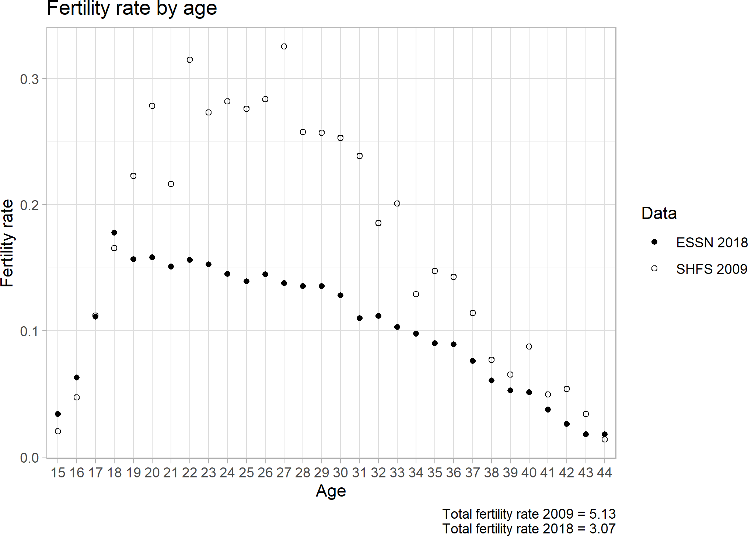
Figure 4 Fertility rates of Syrian women before the war (PAPFAM 2009) versus those of Syrian refugees in Turkey post-conflict (ESSN 2018)

Impact of ESSN on fertility outcomes

Theoretical model and implementation

Here, we will aim to shed light on the effects of the ESSN programme on the fertility of its target population. Our interest is to ascertain if the programme indeed has an impact on the fertility behaviours of its applicants and beneficiaries. It should be noted that this part of the analysis also includes not only Syrians but also other refugees such as Iraqis and Afghans.
To begin, the probability of having a child between April 2018 and April 2019 among ESSN beneficiaries is nearly 14%, while the same probability among ineligible applicants was slightly over 10.5%. The difference between these two findings, as well as raw regression estimates, result in treatment effect estimates between 2.4 and 3 percentage points. However, these estimates are severely biased since the number of children is one of the selection criteria of the ESSN programme.

Logit model specification

As outlined earlier, the propensity score is estimated through a logit model on a dummy variable that indicates whether or not a given household is eligible.
The selection of explanatory variables to be included in the propensity score matching is crucial. Indeed, those covariates should satisfy both unconfoundedness and overlap conditions. Therefore, omitting important variables could consequently increase bias in our estimates. However, due to the overlap condition, we were also careful not to include too many predictors in the X vector; perfect predictors cannot be used in matching. In order to keep some randomness, only those variables which simultaneously influence the participation decision and the outcome variable should be included. This allows for individuals with similar characteristics to be observed in both states.
Indeed, one potential obstacle to achieving good balance is the presence of strong selection into the treatment (Augurzky and Schmidt 2001). We therefore attempted to choose a minimal set of covariates to satisfy unconfoundedness. This element, in addition to the trimming of the extreme values of the propensity score, ensures better overlap in the case of strong selection (Crump 2009).

Given these conditions, we chose to include the following covariates in the logit model:
- Acceptance Criteria 1 (Single Parent)
- Acceptance Criteria 6 (Over 4 children)
- Number of months since the first application to the ESSN programme
- Nationality of the household’s main ESSN applicant
- Region in which the household is situated
- Structure of the household (by age group)

The choice to use two ESSN criteria is justified for the following reason:
As demonstrated previously, some ineligible households meet the eligibility criteria despite not being beneficiaries. Our objective is to build the best propensity score. Considering that available variables are scarce (due to the administrative nature of the data), we have no other option than to use the few variables that were available to us. The results demonstrate that the chosen explanatory variables are, in fact, accurate predictors in establishing a propensity score for the programme’s eligibility status.

General results of the model

The average treatment effect was estimated with the overall processed database. The various methods explained above lead to slightly different, though consistent, average treatment effects. A summary table of the results is presented below, however, a detailed analysis can be found in the appendix section.

The results presented in Table 1 reveal that eligible households are 3 to 6 percent more likely to have an additional child in the year following observation. This result rejects the first hypothesis. Eligible and ineligible applicants thus have different trends in fertility. Note that the “delta in means” result can also be interpreted in terms of children per woman. The average effect of the ESSN is about +0.06 children per year per woman for ESSN beneficiaries compared to ineligible households. This suggests that beneficiaries of the ESSN programme are more likely to have +0.06 more children per year than ineligible households.

 | Delta in means | Regression
 |  | No controls | With covariates
2NN | 0.061 | 0.058 | 0.048
Stratified | 0.020 | 0.027 | 0.053
Table 1 Summary of treatment effects on the full dataset, impact of eligibility on chances of having a child in the year following observation

The observations that we can draw from these first estimations point out an effect of the programme on giving birth. Here it is interesting to note that among Syrians – who represent on average 89% of the ESSN beneficiary population– fertility levels for all ages remain lower than before the war. Therefore, the programme seems to increase stability in households and impact birth rates in this way. The second hypothesis, which suggests that the ESSN has an impact on its beneficiaries’ fertility behaviour, is accepted. Beneficiary couples are more likely to have children than ineligible applicants. This can be interpreted as a positive impact of the ESSN that helps refugees to stabilize and settle in the host country to have favourable conditions to have children. Couples who could not afford to have more children before the programme are now able to, thanks to the monetary assistance provided to them by the ESSN. Consequently, the last hypothesis, which suggests that ineligible applicants would have more children so as to become beneficiaries, is rejected. Ineligible applicant couples are less likely to have children than the beneficiary couples.

All of the above findings are further supported by qualitative evidence from focus group discussions. When participants were asked during discussions for their ideal number of children, we observed that this number has decreased since their arrival in Turkey. Participants over 40 who arrived from Syria when they were 30 and above were more likely to want 5 or more children. Indeed, this number was lower among younger participants and those who already gave birth in Turkey. The reported ideal number of children varied mostly from 3 to 4. As reasoning, participants mentioned that the costs related to having a child are much higher in Turkey than in Syria. As a result, they reported a decrease in their own ideal number of children since their arrival in Turkey. One participant explained, ‘I had 5 children in Syria and 2 children here, I would have had more if we stayed in Syria because I always wanted twins and now there are sorts of injections and treatments that allow that’. These findings prove a decrease in desire for children among Syrian migrants since their arrival in Turkey. Most beneficiaries claimed that ESSN assistance is insufficient in covering all living expenses and that mostly this assistance is used to pay rent.
Additionally, access to health care plays an important role in Turkey. Since most programme beneficiaries as well as ineligible applicants are registered as refugees in Turkey, they have free access to the health care services. When female participants were asked about women’s health care in Turkey, they reported being satisfied with the services they received before, during and after pregnancy. However, a few participants did report negative experiences related to the treatment they received when giving birth in a hospital. For example, some reported that doctors were criticizing women for having too many children. Nearly all women had given birth in a hospital and the majority of them had already given birth since their arrival in Turkey. Many of these women had knowledge about contraceptives and reported mostly using the pill when needed back in Syria. In Turkey, there are many women’s health centres and hospitals where contraceptives are available if needed. Some Syrian migrant women reported making the decision to use contraceptives together with their husband if they wish to increase the time between children.

Treatment Effect by Number of Children in Household

In addition to comparing the number of additional children, we also observed the impact of eligibility status on the probability of having an additional child in subgroups of our population, depending on the number of children already present in the household. This is important as one of the demographic criteria is dependency ratio; in which the ineligible households with 2 children, might want to have the 3rd child in order to become eligible. If ineligible households did in fact consider the eligibility criteria when deciding if or when they would have a child, this would be observable for those households who have 2 children already. A summary of the results is presented below in Table 2.

 | Delta in means | Regression
 |  | No controls | With covariates
1 child | 0.057 | 0.053 | 0.061
2 children | 0.039 | 0.021 | 0.021
3 children | 0.063 | 0.079 | 0.069
Table 2 Summary of treatment effects on subsets by number of children, impact of eligibility on chances to have a child in the year following observation

Indeed, the average treatment effect of eligibility decreases for those households that already have 2 children as compared to households with only one child as well as those with three children. This could indicate a counter-intuitive effect of ineligibility on the likelihood to have a third child. As a result, the hypothesis suggesting that the ESSN has a differential impact on fertility according to birth order, is accepted. The ESSN does not have the same impact on the probability of having a second, third or fourth child. For both the second and the fourth child, the effect is an increase of about 0,06 children per year, per woman. However, the effect on the third child is an increase of about 0,04 children per year, per woman.

Impact of the ESSN on fertility calendars

The estimated treatment effect reveals that the ESSN programme has a positive impact on the probability of a household having an additional child. This may be attributed to the effect that an additional and regular source of income has on living conditions in a household. Indeed, the ESSN may create more stable living conditions, which enables household recipients to have more children than those households which are ineligible. However, migrant fertility rates in Turkey remain lower than overall fertility rates in Syria before the war (see Figure 4).
The impact of the programme is less for households that already have two children prior to receiving the assistance. In this section, we will explore the differential effect of ESSN on fertility according to birth order following the hypothesis of the counterintuitive effects of ESSN on fertility calendars.
One possible explanation for this result could be the potential incentive induced by the programme eligibility conditions. Indeed, an ineligible household with two adults becomes eligible as soon as they have three children. However, this effect seems to be quite limited (the difference is only one month), and the overall treatment effect induced by the programme goes in the opposite direction. Nonetheless, a possible consequence of the effect could be that ineligible couples have their third child sooner than they might otherwise.

Interval between two births: Data pre-processing

The estimation strategy used here is the same as for the results by subgroups. Indeed, the logit regression, propensity score estimation and matching strategies remain the same. The only difference is the outcome variable, that is the interval between two births. This is computed as the gap (in months) between older siblings and each subsequent child born to parents that are recipients of the programme.
In order to compute the interval between two births, we isolated the children born during the programme for each birth-order position (i.e., first child, second child, etc.) and then computed the difference (in months) between the child’s date of birth and that of his/her older sibling. Given that this processing is quite specific, the resulting data frame for a single month would have an insufficient number of observations for the estimations to be reliable.

Therefore, the database was constructed at the household level. Similar to the database used for the first estimations, this one had the addition of the new variable indicating the interval between the first and the second child as well as between the second and the third child for April 2019. Next, the same computations were replicated for data from all months dating back to April 2018. We also added to the first database all households that were not previously included, and which had intervals between births.

Results

The results presented in Table 4 below confirm the impact of eligibility on birth timings. Note that the “delta in means” result can be interpreted as a difference in months. The treatment effect of eligibility is generally 4 months while the same treatment effect is an increase of about 1 month for the interval between second and third children. This means that, all others being equal, eligible households are more likely to have children as well as to have their second child sooner than ineligible households. On the contrary, ineligible households have their third child sooner than eligible households.

 | Delta in means | Regression
 |  | No controls | With covariates
b/w 1st & 2nd children | -3.73 | -2.65 | -2.69
b/w 2nd & 3rd children | 0.76 | 1.12 | 1.11

Table 3 Impact of Eligibility on interval between two births

Considering that the average interval between the first and second child is about 30 months and that the average interval between later births is about 40 months differences in terms of fertility timing are slight. Nonetheless, the last hypothesis is still accepted. ESSN beneficiaries were found to have their second child four months earlier than ineligible households. Therefore, participating in the programme shortens the interval between first and second child births. On the contrary, ineligible women have their third child one month sooner than beneficiary women. In other words, the programme impacts the interval between the second and the third child.

Discussion

During this research, we aimed to understand the impact of demographic criteria on the fertility behaviour of Syrian refugees for cash-based transfers. Our first hypothesis was focusing on the impact of targeting criteria on the fertility rates which was suggesting that ESSN beneficiary status has no impact on the fertility and both beneficiaries and non-beneficiaries have similar fertility rates. Our literature review focused on the impact of cash transfers on fertility as a whole as there was no specific literature for migrant populations on the subject. However, one of rare the studies by Arc (1996) suggested that childbearing behaviour is barely affected by welfare benefits (Sleebos 2003). On the contrary, our study found that the programme does, in fact, have an impact on fertility among beneficiaries which responded to our second hypothesis that beneficiaries are more likely to have more children after becoming eligible. Here, it should be noted that this study is calculating the fertility rates through own children method which focuses on the birth given in the previous year that allowed us to compare beneficiaries and non-beneficiaries since they applied to the ESSN. The ESSN programme is designed to provide basic needs for the most vulnerable refugees. The results demonstrated that eligible and ineligible households were not found to have the same fertility trends. The average effect is an increase of about 0.06 more children per year per woman for ESSN beneficiaries, as compared to ineligible applicants. This hypothesis also showed that ESSN does not increase the fertility rates for non-beneficiaries to become eligible for the ESSN programme by having 4+ children and/or a dependency ratio equal to or greater than 1.5. These findings showed that ESSN beneficiaries tend to have more children that would be related to having more stable conditions to have children as ESSN beneficiaries.
In order to understand the impact on the fertility behaviour from different aspects, not only we compared the fertility rates but also, we examined the calendar effect and the birth rank to assess the differences on eligible and ineligible ESSN applicants. Our 4th hypothesis was that the ESSN has a differential impact on fertility according to the birth order of children. The probability of having the 1st, the 2nd or 3rd child is not equally affected by the ESSN demographic criteria. Especially as one of the demographic criteria was dependency ratio which equals having 3 children and 2 adults can deem household eligible, the hypothesis was defending that the non-beneficiary households would have 3rd child to become eligible. The results demonstrated that the effect of the programme on having a 2nd child and on having a 4th child is an increase of about 0.06 children per year per woman for ESSN recipients. The effect of the programme on having a 3rd child is an increase of about 0.04 children per year per woman for ESSN beneficiaries.
The last hypothesis was that ESSN has an impact on fertility calendars. The intervals between successive births are different for ineligible households than for those households that will meet the ESSN demographic criteria if they have a 3rd child, or for beneficiaries who are already part of the ESSN. Toulemon (2004) addressed that there is a disruption effect for most migrant populations where they settle and wait to have children which is disrupted at the time of migration. For the case of the ESSN, it might be that families would slightly modify the time of the 3rd children to become eligible for the programme. Indeed, the results showed that the ESSN also has a differential impact on fertility according to the birth order of children. The main impact of the ESSN is on the timing of childbearing. The average interval between the first and second child is 30 months. The average interval between subsequent children is 40 months. The programme thus shortens the interval between the 1st and 2nd child by about 4 months. In other words, those who are eligible have their second child four months earlier than those who are ineligible. Conversely, the programme extends the interval between the 2nd and 3rd child by 1 month. This counterintuitive effect must be interpreted as follows: the existence of ESSN is an incentive for ineligible couples with two children to have a third child sooner, so as to become eligible via the dependency ratio equal to 1.5 criterion. This incentive also explains the lower effect of the ESSN on the 3rd child (increase of 0.04 per woman per year versus an increase of 0.06 for other children). Ineligible couples with 2 children might also be interested in having a third child in order to become eligible.
Independent from the case ESSN, if we focus on the fertility rates among the refugees since their arrival in Turkey; the study shows that the fertility decreased. Syrians have lower fertility rates compared to 2009 which drastically changed from 5.13 to 2.07 in 2019. This proves the theory of Hills (2004) that fertility often tends to decrease in the aftermath of crisis and conflict as in the case of the Syrian refugees in Turkey. It is also worth to note that Syrian population was already under demographic transition from 2009 where fertility was already on a gradual decrease.
Overall, this article focused on the impact of ESSN on fertility behaviour. However, there have been similar research papers focusing on the targeting impact of the ESSN. One such study was currently published by the World Bank called Children on the Move: Progressive Redistribution of Humanitarian Cash Transfers among Refugees. This study was focusing on the impact of ESSN for refugees. One of the main results provides prima facie evidence that the programme quickly caused substantial changes in household size and composition, with a net movement of primarily school-age children from larger ineligible households to smaller eligible ones (Özler, et al. 2020). In other words, once households knew whether they were eligible or not, they rearranged their households, with children from larger and poorer households moving towards ones that were smaller and better off. That shows that the targeting criteria of ESSN not only affected the fertility behaviour but also the household composition of ESSN applicants.
Another report published by the Oxford Policy Management focusing on the impact of ESSN and its success on truly reaching the poor. That report was an independent evaluation of the ESSN programme in 2018. The main findings showed that the homogenous structure of the refugee population makes it difficult to differentiate between poor and non-poor households, which is an expected result in humanitarian context as many households tend to be below or just above the poverty lines. The study also concluded that the demographic targeting criteria allowed a rapid scale up of the programme, but are a blunt instrument to differentiate in a homogenous population (Maunder, et al. 2018).
In a nutshell, this study concludes that as much as the demographic criteria is a good solution for rapid scale up of programmes particularly for homogenous population groups as in the case of refugees in Turkey, slight demographic changes are inevitable. However, this study proved that this impact would come along with other reasons to have the final decision of having children which in the end decreased the impact of the ESSN programme on fertility decisions. The most important impact will be found in the timing of having the children rather than the overall birth rates.

Bibliography
Acs, Gregory. 1996. "The Impact of Welfare on Young Mothers’ Subsequent Childbearing Decisions." The Journal of Human Resources (31) 4: 898-915.
Agadjanian, Victor. 2018. "Interrelationships of Forced Migration, Fertility and Reproductive Health." In Demography of Refugee and Forced Migration, by Hugo Graeme, J. Mohammad Abbasi-Shavazi and P. Ellen Kraly, 113-125. Cham: International Studies in Population.
Augurzky, Boris, and Christoph M. Schmidt. 2001. "The Propensity Score: A Means to An End." IZA Working Papers, 1-37.
Becker, Gary S. 1960. "An Economic Analysis of Fertility: In Demographic and economic change in developed countries." Princeton University Press (National Bureau of Economic Research) 209-231.
Becker, Gary S., and Gregg Lewis. 1973. "On the Interaction between the Quantity and Quality of Children." Journal of Population Economics 81 (2): 279-288.
Caliendo, Marco, and Sabine Kopeinig. 2008. "Some practical guidance for the implement- tation of propensity score matching." Journal of Economic Surveys 22 (1): 31-72.
Clark, Gregory. 2019. "Welfare reform, 1834: Did the New Poor Law in England produce significant economic gains?" Cliometrica 13 (2): 221-244.
Coleman, D. 1994. "Trends in Fertility and Intermarriage among Immigrant Populations in Western Europe as Measures of Integration." Journal of Biosocial Science 107-136.
Crump, Richard. 2009. "Dealing with limited overlap in estimation of average treatment effects." Biometrika 96 (1): 187-199.
Department of Statistics (DOS) and ICF. 2019. " Jordan Population and Family and Health Survey 2017-18." Amman, Jordan and Rockville, Maryland.
Desiderie, Rene. 2020. The Impact of International Migration on Fertility: An Empirical Study. Working paper, Washington, DC: KNOMAD.
Fargues, Philippe. 2006. "The Demographic Benefit of International Migration: Hypothesis and Application to Middle Eastern and North African Contexts." World Bank Policy Research Working Paper, European University Institute.
Hacettepe University, Institute of Population Studies. 2019. 2018 Turkey Demographic and Health Survey Syrian Migrant Sample. Ankara, Turkey: T.R. Presidency of Turkey Directorate of Strategy and Budget and TÜBİTAK. http://www.hips.hacettepe.edu.tr/tnsa2018/rapor/2018_TDHS_SR.pdf.
Hill, K. 2004. War, humanitarian crisis, population displacement and fertility: A review of evidence. Washington, D.C.: The National Academies Press.
Hynes, M., M. Sheik, H.G. Wilson, and P. Spiegel. 2002. "Reproductive health indicators and outcomes among refugee and internally displaced persons in post-emergency phase camps." 595–603. doi: https://doi.org/10.1001/jama.288.5.595.
Kulu, Hill, Tina Hannemann, Ariane Pailhé, Karel Neels, Sandra Krapf, Amparo González‐Ferrer, and Gunnar Andersson. 2017. "Fertility by Birth Order among the Descendants of Immigrants in Selected European Countries." Population and Development Review 31-60.
Lam, J. O., R. Amsalu, K. Kerber, J. E. Lawn, B. Tomczyk, N. Cornier, A. Adler, A. Golaz, and W. Moss. 2012. "Neonatal survival interventions in humanitarian emergencies: A survey of current practices and programs." Conflict and Health.
Maunder, Nick, Karin Seyfert, Meltem Aran, Gökçe Baykal, Marta Marzi, and Gabrielle Smith. 2018. Evaluation of the DG ECHO funded Emergency Social Safety Net (ESSN) in Turkey. Decentralized Evaluation, Ankara: Oxford Policy Management.
McGinn, T. 2000. "Reproductive Health of War-Affected Populations: What Do We Know?" International Family Planning Perspectives, 26 ed. doi: https://doi.org/10.2307/2648255.
MoSFP. 2017. https://ailevecalisma.gov.tr/SYGM/PDF/Turkeys_integrated_social_assistance_system.pdf.
Özler, Berk, Çiğdem Çelik, Scott Cunningham, P. Facundo Cuevas, and Luca Parisotto. 2020. Children on the Move: Progressive Redistribution of Humanitarian Cash Transfers among Refugees. Policy Research Working Paper, Washington D.C.: World Bank.
Page, Marianne, and Gregory Clark. 2008. Welfare Reform, 1834. Working Paper, Department of Economics, UC-Davis.
Purière, Aurélien. 2012. "Les effets des revenus d’assistance. Mythe ou réalité ?" ERES 1 (1): 111-124.
Randall, S. 2004. Fertility of Malian Tamasheq Repatriated Refugees: The Impact of Forced Migration. Washington D.C.: National Academies Press.
Siegel, Bernard J. 1970. "Defensive Structuring and Environmental Stress." American Journal of Sociology 11-32.
Sieverding, Maria, Nasma Berri, and Sawsan Abdulrahim. 2018. Marriage and fertility patterns among Jordanians and Syrian refugees in Jordan. Working papers, Economic Research Forum.
Sleebos, Joëlle. 2003. Low Fertility Rates in OECD: Facts and Policy Responses. Working Paper, Paris: OECD.
Thévenon, Olivier. 2004. "Evaluer l’impact des politiques familiales sur la fécondité." CNAF Informations sociales 3 (183): 50-62.
Toulemon, Laurent. 2004. "Fertility among immigrant women: new data, a new approach." Population & Societies, April.
Toulemon, Laurent, and Magali Mazuy. 2003. Comment prendre en compte l’âge à l’arrivée et la durée de séjour en France dans la mesure de la fécondité des immigrants? Documents de travail, Paris: INED.
Volant, Sabrina, Pison Gilles, and François Héran. 2019. "French fertility is the highest in Europe. Because of its immigrants?" Population & Societies 568 (7): 1-4. doi: https://doi.org/10.3917/popsoc.568.0001.
Whittington, Leslie, James Alm, and Elizabeth Peters. 1990. " Fertility and the personal exemption-implicit pronatalist policy in the United States." American Economic Review 80 (3): 545-556.
World Bank. 2020. Fertility rate, total (births per woman)—Syrian Arab Republic and Libya. https://data.worldbank.org/indicator/SP.DYN.TFRT.IN?locations=SY-LY.
World Food Programme. 2020. "Refuges in Turkey: Comprehensive Vulnerability Monitoring Exercise." Rome. https://reliefweb.int/report/turkey/refugees-turkey-comprehensive-vulnerability-monitoring-exercise-round-5-june-2020.
Youssef, Rana. 2012. "Transition de la fécondité et diversités régionales: Le cas de la Syrie." Les Cahiers d’Etudes sur le Monde Arabe et la Méditerranée 21 : 95-112.

The latest data retrieved on 10.03.2021 from https://en.goc.gov.tr/temporary-protection27
Facility table on how the budget was distributed year by year can be found here: https://ec.europa.eu/neighbourhood-enlargement/sites/default/files/facility_table.pdf
Refugees Association document on commonly known facts that are wrong about Syrians – only available in Turkish: https://www.stgm.org.tr/sites/default/files/2020-09/suriyelilerle-ilgili-dogru-bilinen-yanlislar_0.pdf
Unexpected gain in income – in this example it’s about having children anyway which would bring unexpected additional income.
In this case, “raw estimate” indicates an estimate prior to using the propensity score matching method.

