Iraq Social Protection Forum
Terms of Reference (TORs)

DRAFT

February 7, 2019

There is recognition of the importance of aligning humanitarian assistance and development cooperation in Iraq for better coordinated and more sustainable outcomes. Social protection is identified as a key area to be strengthened, particularly in the following areas: (i) harmonizing targeting methods; (ii) leveraging Information Technology; and (iii) referrals and improved linkages beyond cash and in-kind. An action plan, emerging from discussions with the Ministry of Labor and Social Affairs (MOLSA) and humanitarian, development and donors, was developed as an initial roadmap to bridge the humanitarian and development divide in the country (see Annex 1). The organization of a Social Protection Forum was suggested as a first step towards engaging more collectively and efficiently with key Iraqi Government actors, and initially with the MOLSA on the humanitarian and development nexus related to a wide range of social protection issues.

Objectives of the Social Protection Forum
For the purpose of these ToRs, social protection is being operationally defined to refer to national systems that provide income support to address and reduce economic and social vulnerabilities and to ensure access to basic services to all, especially for groups that are vulnerable and excluded. Social protection programs can include various schemes and programs, including (a) social assistance (non-contributory or otherwise called social safety nets), (b) social insurance, (c) employment guarantees and other public employment programs, and (d) measures to facilitate access to education, health and care services.

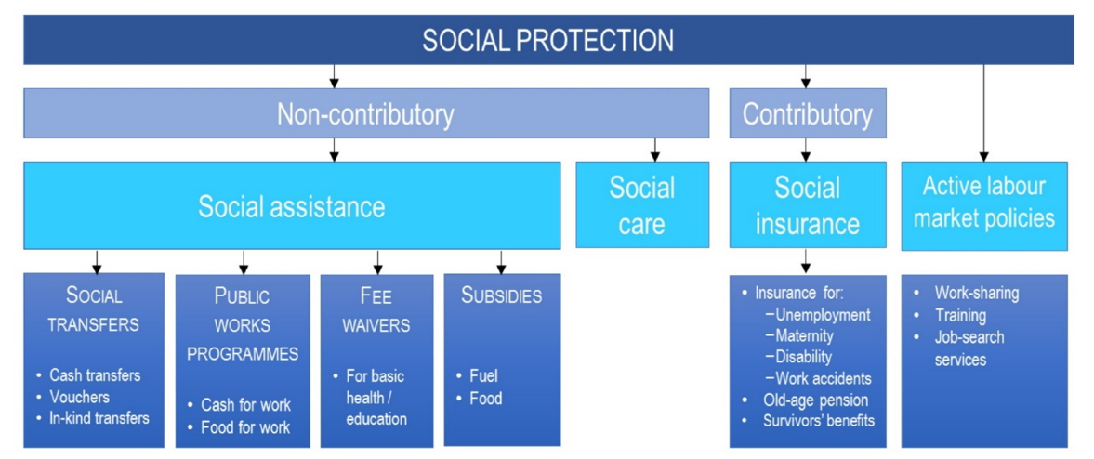

The SPF will initially focus on non-contributory social protection strategies where participants have specific interests or ongoing initiatives to ensure that its goal and activities remain concrete and achievable, thus having a demonstrated effect. However, the SFP’s scope and structure may gradually evolve and will expand to include most areas under social protection. Recognising that the SPF is being initiated in a post-conflict context where new coordination structures and partnerships between international stakeholders and the Government of Iraq are quickly evolving to best achieve a coherent set of social protection policies and programs that facilitate a gradual integration of displaced populations and other vulnerable groups into the Government’s social protection systems, the SPF will remain adaptable in its scope and structure to best integrate – and avoid duplication – as new coordination mechanisms emerge and take shape.
Specifically, the main objectives of the Social Protection Forum include:
- Promote a commonly understood vision of social protection for all actors in Iraq (Government of Iraq, International community and humanitarian actors, including INGOs) in line with national relevant laws and programs;

- Serve as the platform for policy and operational information sharing between humanitarian, development and government actors, including sharing of best practices to inform ongoing and planned social protection efforts in Iraq. Enhanced information sharing is hoped to increase coherence between Government social protection programs and those of development and humanitarian actors, including INGOs;

- Coordinate, and where appropriate harmonise and complement, support by various stakeholders to different government bodies implementing social protection systems;

- Gather feedback and input from development and humanitarian actors to support and advocate for the inclusion of vulnerable populations and the implementation of government social protection policies and programmes;

- Ensure that the assessment of needs, gaps, and responses to social protection issues remains current, evidence-based, and widely understood; and readiness to respond in time of emergency;

- Support the Iraqi Government to develop strategies for more predictable funding.

Annex 2 identifies some of the initial activities that the SPF could be in charge of carrying out. A more thorough discussion on the specific activities that the SPF will be determined and set out in a regularly updated annex document (i.e. annual work plan).
Organizational Structure of the Forum
- It is proposed that the Forum be initially co-chaired by the Poverty Reduction Strategy at Ministry of Planning (MOP) and the World Bank. The international co-chair will rotate on an annual basis, beginning with the World Bank co-chairing.
- Participation will include 1-2 representatives from the following organizations:
  - Government of Iraq ministries (starting with MOLSA and the MOP and gradually including other relevant actors, and specifically Ministry of Trade - MoT, and Ministry of Migration and Displacement - MoMD)
  - UN agencies
  - National and international NGOs, including an NGO Coordination Committee for Iraq (NCCI) representative
  - Humanitarian clusters, sub-clusters, and working groups, including a OCHA Inter Cluster Coordination Group (ICCG) representative
  - International humanitarian and development donors.

Depending upon the outcome and/or issues arising out of specific discussions, the group may be expanded to introduce additional members as relevant.
- Representation at the Social Protection Forum should be at the (senior) level from the participating organizations and (Director General) level from GOI.
- It is proposed that the Forum meets at least once every two months, and that the expected objectives, activities, outputs/results are identified in the form of an agenda and circulated at least a week in advance.
- The Social Protection Forum will nominate a secretariat from within the group, on a rotational basis, every 6 months, to record minutes and co-ordinate meetings, unless and until dedicated resources to the Forum are secured. It is proposed that WFP and UNHCR can jointly serve as the secretariat during the first 6 months.

Annex 1: Action Plan

Preamble:
1.1 Scope: The actions outlined in the below Action Plan were agreed upon by participants of the workshop (CWG members and MoLSA only) and are not representative of a broader range of social protection stakeholders across Iraq who are members of the Social Protection Forum. The actions are more narrowly focused on the key short to medium term foundational activities required to build a stronger relationship and shared understanding of each other’s work between MoLSA and CWG members, to ideally lead to developing a joint vision or roadmap for transition in the future. Where it has already been identified that it would be useful or ideal for additional organisations who were not present at the workshop to participate in an action, they have been listed to be invited, but are not committed to participation.
1.2 Responsibility: The focal point named is responsible for initiating, convening, liaising, and/or coordinating an action with all others so that all actions serve the community as a whole, including MoLSA. Any additional actors should participate who have the interest, resources, and capacity to contribute – they do not have to be named responsible in the document to play a role. There is no one specific “owner” of the Action Plan and accountability is shared between those who committed to lead activities.
1.3 Monitoring Implementation: It has been proposed that the Social Protection Forum monitor the implementation of the plan with periodic check-ins, as all participants of the workshop are also SPF members. Monitoring would include reviewing progress, sharing results, and determining if changed circumstances result in some actions being removed in time.
1.4 SPF Action Plan: However, SPF members and SPF TORS are wider in scope than the workshop or action plan. The SPF has the potential to do more in linking humanitarians to social protection activities. A wider range of activities should be agreed anew with a separate activity/work plan for the Social Protection Forum membership specifically, from 2019 onwards.

Annex 2: Sample activities that could be carried out by the SPF

Initially, some activities to be undertaken by the members of the Social Protection Forum include:
- Map ongoing and planned social protection analytical and operational work implemented by government and non-government stakeholders, including the identification of gaps and unmet needs;
- Share, during each meeting, information on key social protection activities, achievements, and challenges as a way to enhance coordination and synergies;

- Provide progress-to-date on implementation of social protection initiatives, including but not limited to the CWG-MoLSA Action Plan;

- Regularly engage with the humanitarian system to identify and foster a responsible transition from emergency cash support (short-lived assistance) to social protection for the most vulnerable individuals affected by the conflict;

- Support the MoLSA to develop a short and medium-term plan of activities that can be supported by relevant stakeholders with an associated financing strategy, taking into account the CWF-MoLSA Action Plan and any new social protection framework;

As defined by the UNDGA Regional Technical Working Group on Social Protection in “Aligning Social Assistance with National Social Protection Systems”

